CURRICULUM VITAE
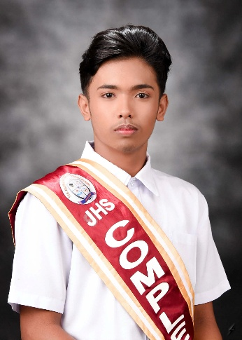

IVAN ALEX D. RECINTO
Brgy. Cambuja,
Santa Maria, Laguna
Contact No.: +63 910 2439 495
Email Address: ivanalexrecinto07@gmail.com

PERSONAL DATA
Date of Birth: May 16, 2008
Place of Birth: Santa Maria, Laguna
Age: 17
Sex: Male
Nationality: Filipino
Civil Status: Single
Religion: Roman Catholic

EDUCATIONAL ATTAINMENT
Secondary Education Sta. Maria Integrated High School
Senior High School
Nusedela St., Brgy. Poblacion IV,
Santa Maria, Laguna
Academic Track − STEM
(A.Y. 2024 - 2026)

Sta. Maria Integrated High School
Junior High School
Nusedela St., Brgy. Poblacion IV,
Santa Maria, Laguna
(A.Y. 2020 - 2024)

Primary Education Paang Bundok Elementary School
Brgy. Cambuja,
Santa Maria, Laguna
(A.Y. 2014 - 2020)

HONORS AND AWARDS RECEIVED
A. Y. 2020 - 2021
- Achiever
A. Y. 2021 - 2022
- Achiever
A. Y. 2022 - 2023
- With Honors
A. Y. 2023 - 2024
- Achiever
A. Y. 2024 - 2025
- With Honors
- Champion − School Based Chant Making
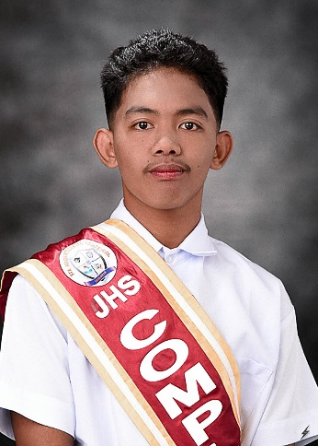

MARC PHILIP A. LANDICHO
Brgy. IV,
Santa Maria, Laguna
Contact No.: ‎+63 956 0550 608
Email Address: philiparmada.landicho@gmail.com
Website: calmbubbles.github.io

PERSONAL DATA
Date of Birth: May 6, 2008
Place of Birth: Santa Maria, Laguna
Age: 17
Sex: Male
Nationality: Filipino
Civil Status: Single
Religion: Christian

EDUCATIONAL ATTAINMENT
Secondary Education Sta. Maria Integrated High School
Senior High School
Nusedela St., Brgy. Poblacion IV,
Santa Maria, Laguna
Academic Track − STEM
(A.Y. 2024 - 2026)

Sta. Maria Integrated High School
Junior High School
Nusedela St., Brgy. Poblacion IV,
Santa Maria, Laguna
(A.Y. 2020 - 2024)

Primary Education Santa Maria Elementary School
Santa Maria, Laguna
(A.Y. 2014 - 2020)

AFFILIATIONS
Infinitrix Club Public Information Officer
(2021 - 2022)

YES-O Public Information Officer
(2022 - 2023)

Grade 10 Representative
(2023 - 2024)

Desert Lake Main Developer
(2022 - Present)

HONORS AND AWARDS RECEIVED
A. Y. 2020-2021
- With Honors
A. Y. 2021-2022
- With High Honors
- Science Quiz Bee Champion
A. Y. 2022-2023
- With Honors
- Science Quiz Bee Champion
A. Y. 2023-2024
- With High Honors
- Science Quiz Bee Participant
- Historical Quiz Bee National Level Qualifier
A. Y. 2024-2025
- With Honors
- PopEd Quiz Bee Participant
- DSPC TV Broadcasting – Technical Director - Participant
- Science Chant Making Champion
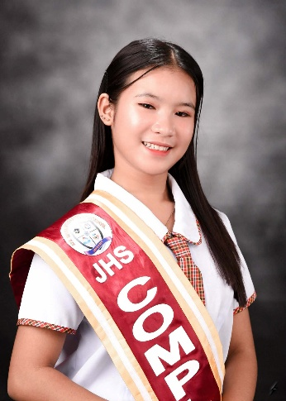

RIANER JUSTIN O. NAMUCO
Sitio Ibaba, Brgy. Nanguma
Mabitac, Laguna
Email Address: rjrianer30@gmail.com

PERSONAL DATA
Date of Birth: January 30, 2008
Place of Birth: Mabitac, Laguna
Age: 17
Sex: Male
Nationality: Filipino
Civil Status: Single
Religion: Roman Catholic

EDUCATIONAL ATTAINMENT
Secondary Education Sta. Maria Integrated High School
Senior High School
Nusedela St., Brgy. Poblacion IV,
Santa Maria, Laguna
Academic Track − STEM
(A.Y. 2024 - 2026)

Sta. Maria Integrated High School
Junior High School
Nusedela St., Brgy. Poblacion IV,
Santa Maria, Laguna
(A.Y. 2020 - 2024)

Primary Education Nanguma Elementary School,
Brgy. Nanguma,
Mabitac, Laguna
(A.Y. 2014 - 2020)

HONORS AND AWARDS RECEIVED
A. Y. 2021 - 2022
- With Honor
A. Y. 2022 - 2023
- With Honor
A. Y. 2023 - 2024
- With Honor
A. Y. 2024 - 2025
- With Honors
- Champion − School Based Chant Making

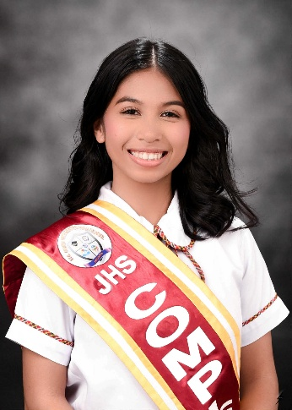

ZCHERHEINE A. TORRERANCA
Padre Burgos St., Brgy. II,
Santa Maria, Laguna
Email Address: zcherheinetorrefranca@gmail.com

PERSONAL DATA
Date of Birth: December 19, 2007
Place of Birth: Santa Maria, Laguna
Age: 17
Sex: Female
Nationality: Filipino
Civil Status: Single
Religion: Roman Catholic

EDUCATIONAL ATTAINMENT
Secondary Education Sta. Maria Integrated High School
Senior High School
Nusedela St., Brgy. Poblacion IV,
Santa Maria, Laguna
Academic Track − STEM
(A.Y. 2024 - 2026)

Sta. Maria Integrated High School
Junior High School
Nusedela St., Brgy. Poblacion IV,
Santa Maria, Laguna
(A.Y. 2020 - 2024)

Primary Education Santa Maria Elementary School
Santa Maria, Laguna
(A.Y. 2014 - 2020)

AFFILIATIONS
YES-O Member
(2022 - 2023)

Science Club Secretary
(2023 - 2024)

HONORS AND AWARDS RECEIVED
A. Y. 2021 - 2022
- Achiever
A. Y. 2022 - 2023
- With Honors
A. Y. 2023 - 2024
- With Honors
- Best Club (Science Club)
A. Y. 2024 - 2025
- With Honors
- Champion − School Based Chant Making

